3.8 Implicit Differentiation

Motivation:
Thus far we have mostly dealt with functions where y is a function of x which, by definition, have only one $y$-value for each $x$-value in the domain (usually tested for graphically by using a vertical line test). However, some graphs/formulas do not define y as a function of x and we are still interested in being able to find the slopes of tangent lines to such curves.

Consider the following curves (for which y is not a function of x):
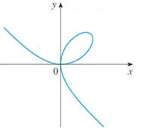
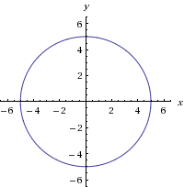
Cannot solve for y
in a single equation

These curves are not functions. Equations like these are called implicit equations. What makes finding a derivative for these curves difficult, is that we defined a derivative as a something we can find for functions!

Definitions:
- An implicit equation is an equation in which one variable is not defined in terms of the other variable.

- An explicit equation is an equation in which one variable is defined in terms of the other variable.

Note: An explicit equation, by definition, is a function.

Example 1: Determine whether each of the following is an implicit or explicit equation.

This is an explicit equation since y is solved for in terms of x. So here y is a function of x.

This is an implicit equation since y is not solved in terms of x.

Note: Although part (b) is not an explicit function, we can use algebra to solve for y. However, this produces two separate functions.
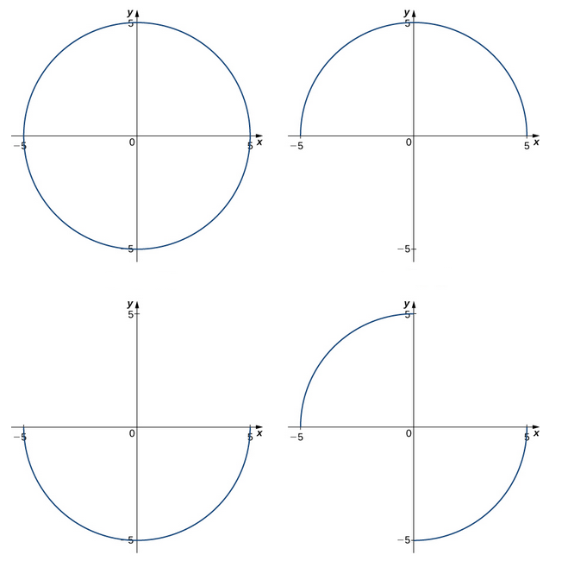
Motivation:

Look at circle and see “hidden” functions

We see that there are many functions that are “hidden” within the graph of the actual circle. Therefore it seems reasonable to say that on a small enough interval we could always find a function hidden in this graph. If such functions do exist then perhaps we can find a derivative.

Example 2: Consider the equation .

- Solve this equation for y.

- Find the equation of the tangent line to the curve at the point .
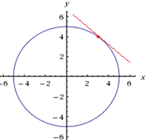
Since we are working with the point we are only looking at the top half of the circle and can therefore use the function .

Therefore, and the equation of the tangent line is:

Example 3: Consider the parabola

- Create a table of values and sketch a picture of this curve.
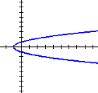
x | y
3  0  -1  0  3 | -2  -1  0  1  2

- Find the equation of the tangent line to the curve at the point .

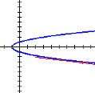
Since we are working with the point we are only looking at the bottom half of the parabola and can therefore use the function .

Therefore, and the equation of the tangent line is:

Question: Why would finding the equation of the tangent line on the graph of at the point be difficult?

Finding the equation of this tangent line would be difficult because we cannot solve the given equation for y very easily. It is possible (though is quite difficult) to solve for y as several functions of x. Luckily, in certain instances, there is a method for calculating even when we are unable to solve for y.
Definition: Implicit Differentiation is a method for computing the derivative of an implicit equation with respect to the variable x while treating all other variables as unspecified functions of x.

Note: In the book the following unsatisfying statement is made: “The technique of implicit differentiation allows us to find the derivative of an implicitly defined function without ever solving for the function explicitly.” This leads to several very important questions:
- What does it mean for y to be implicitly a function of x?
- When will the method of implicit differentiation fail?
Unfortunately, the answers to these questions are beyond the scope of the course. The answers are hinted at in Calculus II and Calculus III. However, one really needs the Implicit Function Theorem which is proven in advanced Real Analysis, to give truly satisfying answers to both of these questions. So, in Calculus I we are in the very unsatisfying position of having to assume that we will only run into questions where implicit differentiation will work.

Example 4: Consider again the equation .

- Find .

We differentiate both sides of the given equation with respect to x. The most complicated part of this is that we have to use the chain rule in order to differentiate with respect to x. In particular, we obtain:

as long as (Note: From the diagram in the motivation we see we have a vertical tangent when y is zero).

Note: We can also see that this derivative agrees with our derivative from Example 2. This is because we know that we are working with the function and so we have:

- Find the equation of the tangent line to the circle given by at the point .


Using the derivative from part (a) we have
Therefore, the equation of the tangent line is:

Note: This result agrees with what we found in Example 2. Notice then that either approach is acceptable, but Implicit Differentiation is our only option when solving for y is impossible!
Example 5: Consider the function .

- Find .

We differentiate both sides of the given equation with respect to x. We obtain:

- Find the equation of the tangent line to the curve given by at the point .

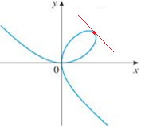
Using the derivative from part (a) we have
Therefore, the equation of the tangent line is:

- What does the derivative evaluate to be at the point ?

Here we can see that , which is an indeterminate form. Since no simplification of the derivative can be done we see that the technique of Implicit Differentiation cannot find the slope of a tangent line at the point .

If we look at the graph of the curve, this actually makes sense since the curve seems to have two different directions at this point. See the pictures below.
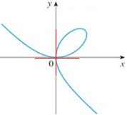

Note: In general the process of Implicit Differentiation will not work for a curve at points of self-intersection.

Example 6: Find the first derivative of y with respect to x if .

Following the idea of implicit differentiation, we have:

Example 7: Suppose that .
- Find .

Using the method of implicit differentiation, we obtain:
.

- Assuming that , find .

Using the method of implicit differentiation (Note: We need to use the quotient rule on the right hand side), we obtain:
Now, we know from part (a) that .
So, we have that:

Exploration: Suppose we would like to find derivative formulas for the inverse trigonometric functions. We begin by briefly reviewing the domain and range of these functions.

Function | Domain | Range

Note: The notation does NOT mean raised to the negative one power. The negative one indicates that the function is an inverse function. To avoid having to use the negative one, you may also see inverse trig functions written as , , etc.

Let’s use implicit differentiation to find the first derivative of .
This equation implies that where .
Now, we use the method of implicit differentiation and we find:

Now, we would like a formula for the derivative which depends only on x.
Recall that .
Crucially, we note that if , must be nonnegative. So, under this restriction, .

However, we already know that . So, .
We thus conclude that .

Example 8: Find .
Let . This equation implies that where.
Now, we use the method of implicit differentiation and we find:
We would like a formula for the derivative which depends only on x.
Recall that . Therefore we have:
In order to figure out the sign of this derivative we note that if then and so which implies that . Similarly if then and so which implies that . So, we see that the derivative must always be positive regardless of the value of x. Therefore we write the derivative as: .

Example 9: Find formulas for the first derivative of and .

We follow the idea outlined in the previous examples. Let . This equation implies that where. Now, we use the method of implicit differentiation and we find: .
Recall that . So, .

Now, let . This equation implies that where.
Now, we use the method of implicit differentiation and we find: .
Recall that . So, .
Note: Similarly, we could find formulas for the inverse cosine and the inverse cosecant. The following table summarizes all the derivative formulas of the inverse trig functions.

Derivatives of Inverse Trigonometric Functions:

Example 10: Find the first derivative of .

We note that . So, by the chain rule:

Example 11: Find if .
We note that by the chain rule:

